Clubnight Free Parking Location
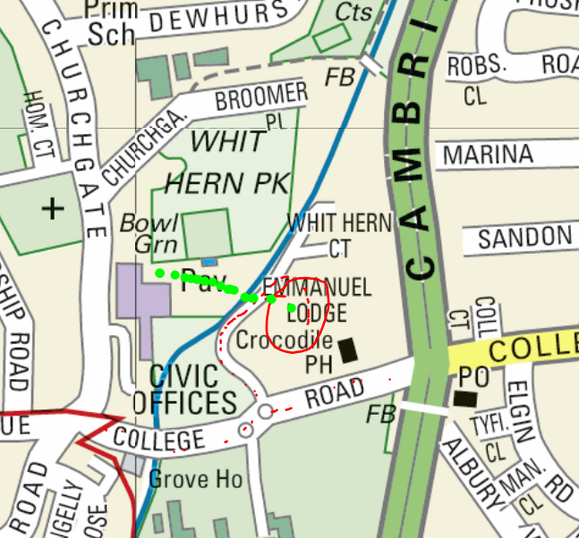

The red circle indicates the free car park area; the green line shows the footpath.

To avoid the parking charge for exceeding the free 2 hour period in the front car park, Use the rear one.
From the A10 crossroads, take the first right at the small roundabout to enter the car park. IGNORE ‘Permit Holders Only’ signs. Once parked, follow the footpath over the bridge and around the lake to reach the Bishops College buildings.

Blue badge holders can use the normal front car park as long as the badge is properly displayed.

You CAN drop off items and passengers in the normal car park before parking if you need to.
.

